|  |  |  |  |
| --- | --- | --- | --- |
| Type of Analytics | Definition | Key Question | Example |
| Descriptive Analytics | Summarizes past data to understand what happened. | *"What happened?"* | Monthly sales reports, website traffic analysis. |
| Diagnostic Analytics | Identifies causes and reasons behind past events. | *"Why did it happen?"* | Analysing customer churn reasons. |
| Predictive Analytics | Uses historical data and machine learning to forecast future trends. | *"What is likely to happen?"* | Predicting next quarter’s sales. |
| Prescriptive Analytics | Recommends actions based on predictions to achieve desired outcomes. | *"What should be done?"* | Suggesting marketing strategies to increase sales. |

# **DATASET = Renewable Energy Consumption**

**1️⃣ Descriptive Analysis (What Happened?)**

**A. Energy Consumption Patterns**

* **Total Monthly Usage by Region & Country**
  + 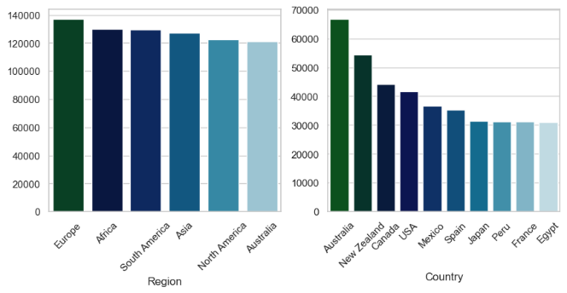Find which **region or country** has the highest renewable energy consumption.

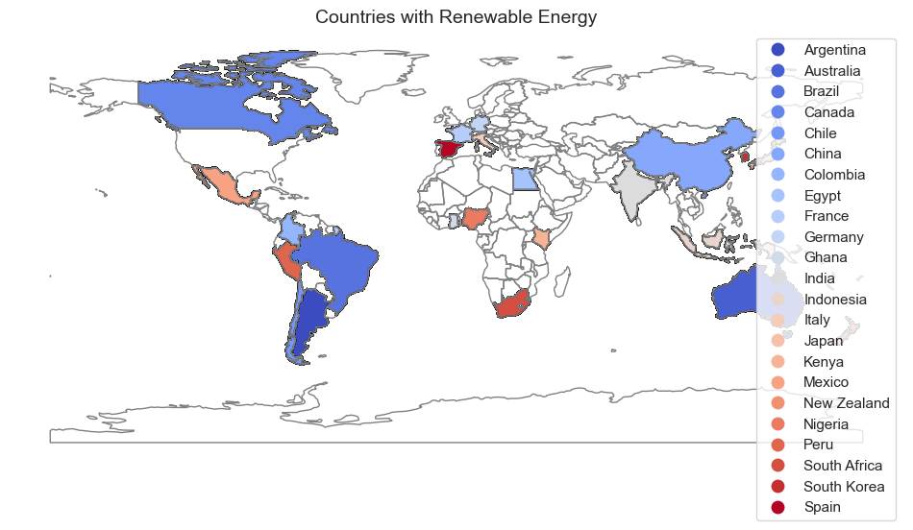

* **Energy Consumption Trends Over Time**
  + 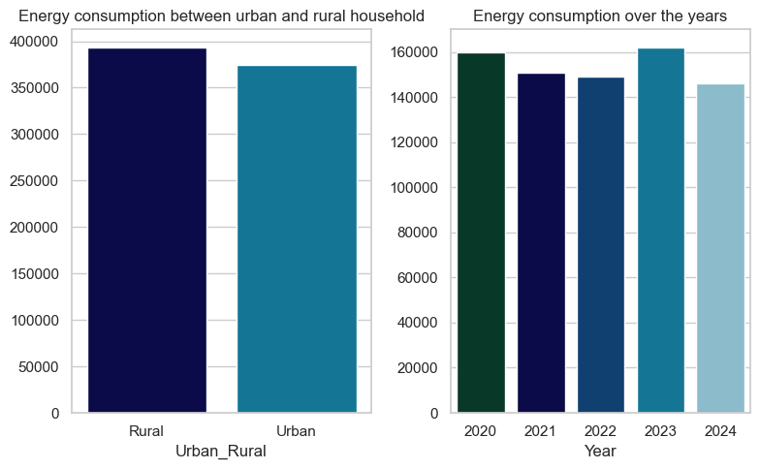Show **yearly** **energy usage** from **different sources** (solar, wind, hydro)

**B. Energy Source Distribution**

* **Most Used Renewable Energy Source**
  + 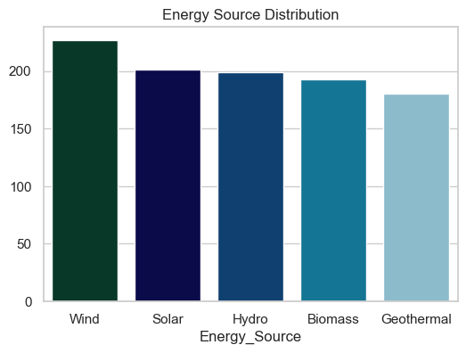Check whether **solar, wind, or hydro** is used the most
* **Urban vs. Rural Energy Adoption** 📊 *(Stacked Bar Chart)*
  + Compare energy usage in **urban vs. rural areas** by energy type.

**C. Household-Level Analysis**

* **Household Size vs. Energy Usage**
  + Do **bigger families** use **more energy**?

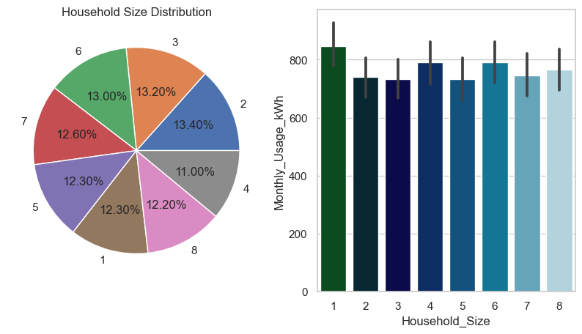

**2️⃣ Diagnostic Analysis (Why Did It Happen?)**

**A. What Affects Energy Usage?**

* **Does income level impact energy usage?**
  + 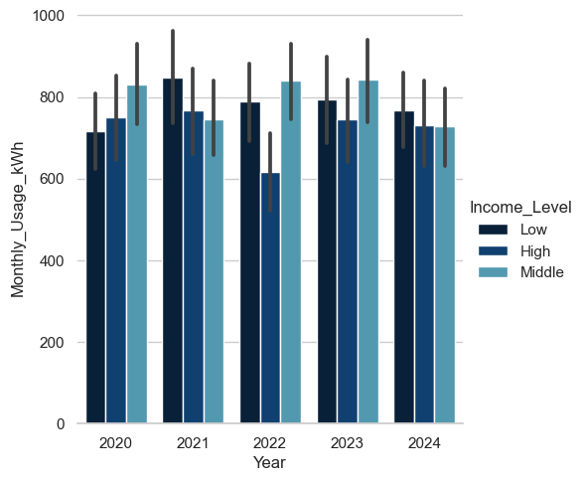Compare **low, middle, and high-income groups** to see if they consume differently.
* **Do subsidies lead to lower energy usage?**
  + 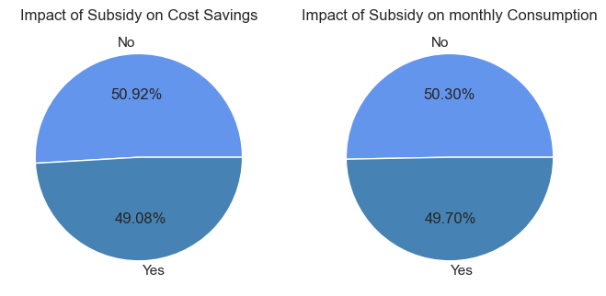Check if **subsidy-received households** have lower consumption.

**B. Adoption Trends & Cost Savings**

* **Has adoption increased over the years?**
  + Find out when most households **started using renewables**.

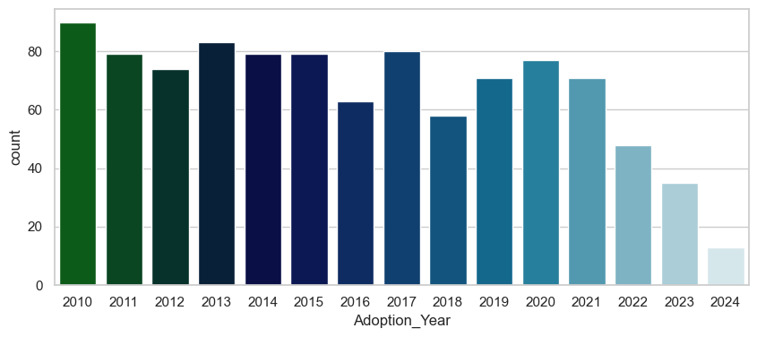

* **Which energy source gives the highest cost savings?** 📊 *(Bar Chart)*
  + 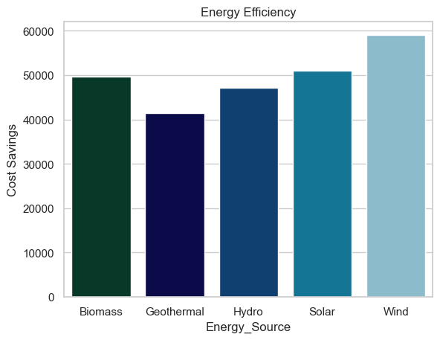Compare **solar, wind, hydro** on **monthly cost savings (USD)**

**Recommendations:**

1. **Promote Renewable Energy in Other Regions** – Since Europe leads in renewable energy usage, similar implementations can be done in other regions to boost adoption.
2. **Encourage High-Income Households** – High-income groups use less renewable energy this may happen due to their high income demands luxurious life. So awareness programs about how renewable energy is useful can encourage their participation.
3. **Enhance Subsidy Impact** – The cost savings and consumption difference for subsidy recipients are minimal (1.84% and 0.60%); improving subsidy programs can make them more effective.
4. **Expand Wind Energy Infrastructure** – Wind energy is the most used and has saved nearly **$60,000** in costs followed by solar energy as it saved **$50,000** cost; further investment in wind and solar power can maximize savings.
5. **Support Rural and Urban Equally** – Since there’s no significant difference in renewable energy usage between urban and rural areas, balanced resource allocation is recommended.
6. **Leverage Economic Downturns for Energy Transition** – The slight increase in renewable energy usage in 2023 due to unemployment suggests that economic downturns could be opportunities to push for sustainable energy adoption.